**Case Study – Burger Bash**

CREATE DATABASE burger_bash;

USE burger_bash;

CREATE TABLE burger_names (

burger_id INT PRIMARY KEY,

burger_name VARCHAR(100));

INSERT INTO burger_names VALUES

(1, 'Beef Burger'),

(2, 'Vegetarian Burger'),

(3, 'Chicken Burger'),

(4, 'Meatlovers Burger');

CREATE TABLE burger_runner (

runner_id INT PRIMARY KEY,

registration_date DATE);

INSERT INTO burger_runner VALUES

(1, '2022-01-01'),

(2, '2022-01-08'),

(3, '2022-01-15');

--DROP TABLE IF EXISTS runner_orders;

--DROP TABLE IF EXISTS customer_orders;

CREATE TABLE customer_orders (

order_id INT,

customer_id INT,

burger_id INT,

exclusions VARCHAR(100),

extras VARCHAR(100),

order_time DATETIME);

CREATE TABLE runner_orders (

order_id INT,

runner_id INT,

pickup_time DATETIME,

distance VARCHAR(20),

duration VARCHAR(20),

cancellation VARCHAR(20));

INSERT INTO customer_orders (order_id, customer_id, burger_id, exclusions, extras, order_time) VALUES

(101, 1, 1, NULL, 'Cheese', '2022-01-05 12:00:00'),

(102, 1, 2, 'Onion', NULL, '2022-01-05 13:10:00'),

(103, 2, 2, NULL, NULL, '2022-01-06 14:05:00'),

(104, 3, 4, NULL, 'Bacon', '2022-01-07 12:05:00'),

(105, 2, 3, 'Lettuce', NULL, '2022-01-08 11:30:00'),

(106, 1, 4, NULL, NULL, '2022-01-08 14:23:00');

INSERT INTO runner_orders (order_id, runner_id, pickup_time, distance, duration, cancellation) VALUES

(101, 1, '2022-01-05 12:30:00', '5km', '30min', NULL),

(102, 2, '2022-01-05 13:40:00', '3km', '20min', NULL),

(103, 1, '2022-01-06 14:31:00', '6km', '33min', 'Cancelled'),

(104, 3, '2022-01-07 12:32:00', '4km', '25min', NULL),

(105, 2, NULL, NULL, NULL, 'Cancelled'),

(106, 2, '2022-01-08 14:56:00', '2km', '10min', NULL);

1. **How many burgers were ordered?**

SELECT COUNT(*) AS total_burgers_ordered FROM customer_orders;

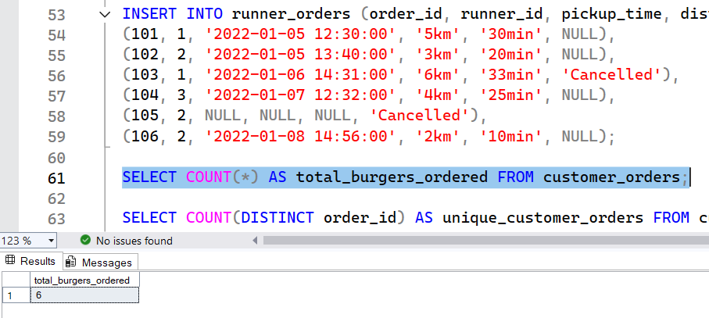

1. **How many unique customer orders were made?**

SELECT COUNT(DISTINCT order_id) AS unique_customer_orders FROM customer_orders;

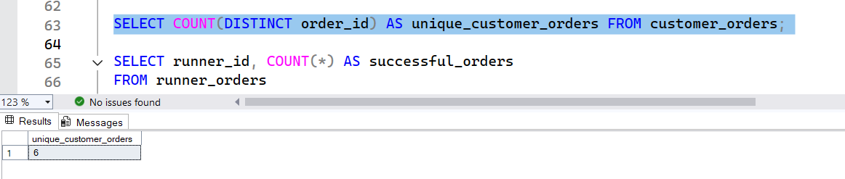

1. **How many successful orders were delivered by each runner?**

SELECT runner_id, COUNT(*) AS successful_orders

FROM runner_orders

WHERE cancellation IS NULL

GROUP BY runner_id;

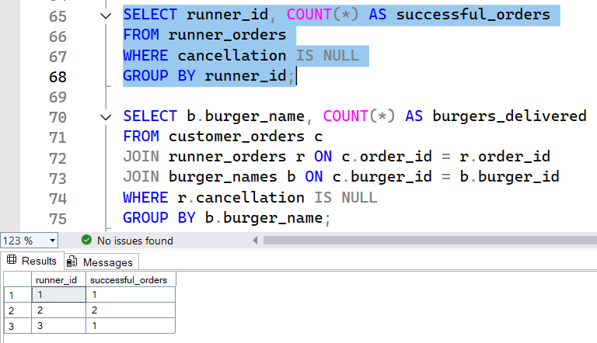

1. **How many of each type of burger was delivered?**

SELECT b.burger_name, COUNT(*) AS burgers_delivered

FROM customer_orders c

JOIN runner_orders r ON c.order_id = r.order_id

JOIN burger_names b ON c.burger_id = b.burger_id

WHERE r.cancellation IS NULL

GROUP BY b.burger_name;

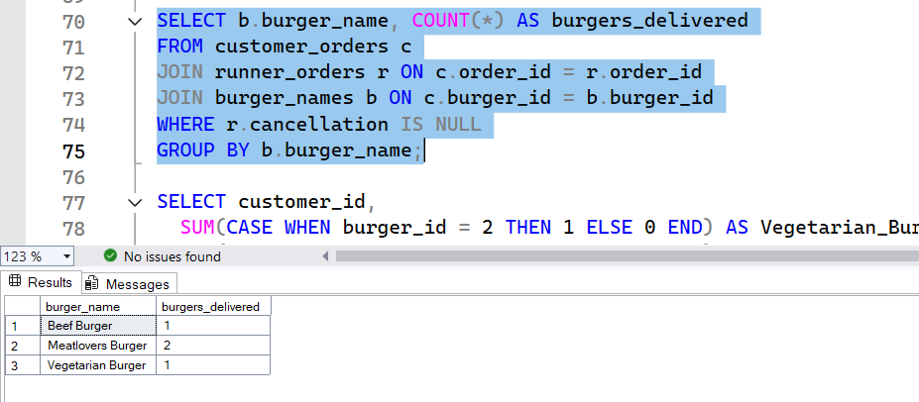

1. **How many Vegetarian and Meatlovers were ordered by each customer?**

SELECT customer_id,

SUM(CASE WHEN burger_id = 2 THEN 1 ELSE 0 END) AS Vegetarian_Burger,

SUM(CASE WHEN burger_id = 4 THEN 1 ELSE 0 END) AS Meatlovers_Burger

FROM customer_orders

GROUP BY customer_id;

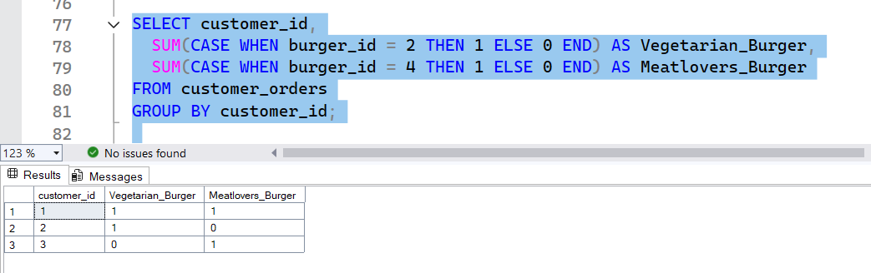

**Submitted by**

Siva Balan T